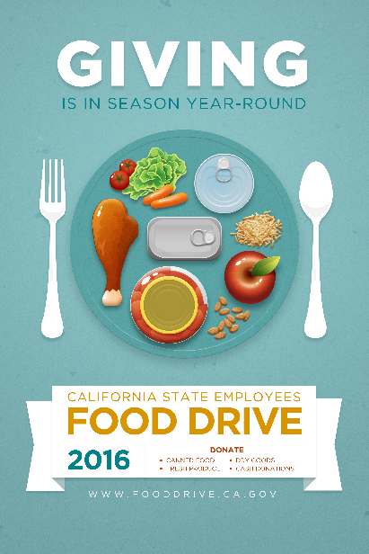

After what is for many a holiday of consuming - that extra slice of thanksgiving pie, Black Friday shopping and cyber Monday deals – Giving Tuesday celebrates and encourages giving to others. People embrace this day as an opportunity to raise money for local nonprofits; teach children about philanthropy; encourage acts of kindness; collaborate with their neighbors; and celebrate generosity.

Giving Tuesday is a global giving movement that has been driven by individuals, families, organizations, businesses and communities in all 50 states and in countries around the world. Since its founding in 2012, millions of people have come together to support and champion the causes they believe in and the communities in which they live.
This movement is the result of the collective power of a unique blend of partners—nonprofits large and small; businesses and corporations; schools and universities; civic campaigns in cities, states and regions; and families and individuals—to inspire people to take collaborative action to improve their local communities and contribute in countless ways to the causes they believe in. Everyone has something to give.

Need one more reason to give? People who give money to charity are 43% more likely than non-givers to say they are “very happy” about their lives.

Let’s get into the holiday spirit and get to giving! Visit the California State Employees Food Drive website http://www.fooddrive.ca.gov/Deposit.asp to see how you can contribute. Choose the agency you want to donate on behalf of by choosing from the list of “Online donation links by Agency”.

To learn more about the 2016 California State Employees Food Drive please visit the 2016 California State Employees Food Drive website at http://www.fooddrive.ca.gov/ or contact your agency coordinator.

