2 cans of tuna
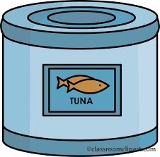

2 cans of tuna

2 cans of tuna

2 cans of tuna

2 cans of tuna

2 cans of tuna

2 cans of tuna

2 cans of tuna

2 cans of tuna

2 cans of tuna

2 cans of tuna

2 cans of tuna

2 cans of tuna

2 cans of tuna

2 cans of tuna

2 cans of tuna

2 cans of tuna

2 cans of tuna

2 cans of tuna

2 cans of tuna

2 cans of tuna

3 cans of vegetables
Low Sodium if Possible

3 cans of vegetables
Low Sodium if Possible

3 cans of vegetables
Low Sodium if Possible

3 cans of vegetables
Low Sodium if Possible

3 cans of vegetables
Low Sodium if Possible

3 cans of vegetables
Low Sodium if Possible

3 cans of vegetables
Low Sodium if Possible

3 cans of vegetables
Low Sodium if Possible

3 cans of vegetables
Low Sodium if Possible

3 cans of vegetables
Low Sodium if Possible

3 cans of vegetables
Low Sodium if Possible

3 cans of vegetables
Low Sodium if Possible

4 Mac & Cheese
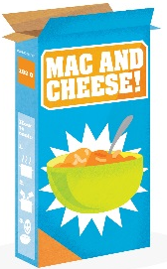

4 Mac & Cheese
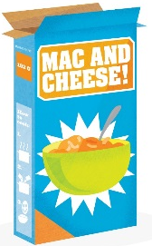

4 Mac & Cheese

4 Mac & Cheese

4 Mac & Cheese

4 Mac & Cheese

4 Mac & Cheese

4 Mac & Cheese

4 Mac & Cheese

4 Mac & Cheese

4 Mac & Cheese

4 Mac & Cheese

4 Mac & Cheese

4 Mac & Cheese

4 Mac & Cheese

1 Jar Peanut Butter

1 Jar Peanut Butter

1 Jar Peanut Butter

1 Jar Peanut Butter

1 Jar Peanut Butter

1 Jar Peanut Butter

1 Jar Peanut Butter

1 Jar Peanut Butter

1 Jar Peanut Butter

1 Jar Peanut Butter

1 Jar Peanut Butter

1 Jar Peanut Butter

1 Jar Peanut Butter

1 Jar Peanut Butter

1 Jar Peanut Butter

3 Bags of Dried Beans
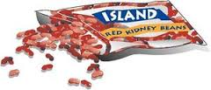

3 Bags of Dried Beans

3 Bags of Dried Beans

3 Bags of Dried Beans

3 Bags of Dried Beans

3 Bags of Dried Beans

3 Bags of Dried Beans

3 Bags of Dried Beans

3 Bags of Dried Beans

3 Bags of Dried Beans

3 Bags of Dried Beans

3 Bags of Dried Beans

3 Bags of Dried Beans

3 Bags of Dried Beans

3 Bags of Dried Beans

1 Container Infant Formula

1 Container Infant Formula

1 Container Infant Formula

1 Container Infant Formula

1 Container Infant Formula

1 Container Infant Formula

1 Container Infant Formula

1 Container Infant Formula

1 Container Infant Formula

1 Container Infant Formula

1 Container Infant Formula

1 Container Infant Formula

1 Container Infant Formula

1 Container Infant Formula

1 Container Infant Formula

2 Dry Goods of Choice
Rice, pasta, cereal, beans, oats, etc.

2 Dry Goods of Choice
Rice, pasta, cereal, beans, oats, etc.

2 Dry Goods of Choice
Rice, pasta, cereal, beans, oats, etc.

2 Dry Goods of Choice
Rice, pasta, cereal, beans, oats, etc.

2 Dry Goods of Choice
Rice, pasta, cereal, beans, oats, etc.

2 Dry Goods of Choice
Rice, pasta, cereal, beans, oats, etc.

2 Dry Goods of Choice
Rice, pasta, cereal, beans, oats, etc.

2 Dry Goods of Choice
Rice, pasta, cereal, beans, oats, etc.

2 Dry Goods of Choice
Rice, pasta, cereal, beans, oats, etc.

2 Dry Goods of Choice
Rice, pasta, cereal, beans, oats, etc.

2 Dry Goods of Choice
Rice, pasta, cereal, beans, oats, etc.

2 Dry Goods of Choice
Rice, pasta, cereal, beans, oats, etc.

2 Canned Soups
Low Sodium if Possible

2 Canned Soups
Low Sodium if Possible

2 Canned Soups
Low Sodium if Possible

2 Canned Soups
Low Sodium if Possible

2 Canned Soups
Low Sodium if Possible

2 Canned Soups
Low Sodium if Possible
2 Canned Soups
Low Sodium if Possible

2 Canned Soups
Low Sodium if Possible

2 Canned Soups
Low Sodium if Possible

2 Canned Soups
Low Sodium if Possible

2 Canned Soups
Low Sodium if Possible

2 Canned Soups
Low Sodium if Possible
2 Canned Soups
Low Sodium if Possible

2 Canned Soups
Low Sodium if Possible

2 Canned Soups
Low Sodium if Possible

2 Canned Soups
Low Sodium if Possible

2 Canned Soups
Low Sodium if Possible

2 Canned Soups
Low Sodium if Possible

3 Cans of Beans
Low Sodium if Possible
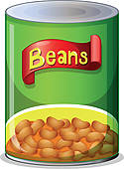

3 Cans of Beans
Low Sodium if Possible

3 Cans of Beans
Low Sodium if Possible

3 Cans of Beans
Low Sodium if Possible

3 Cans of Beans
Low Sodium if Possible

3 Cans of Beans
Low Sodium if Possible

3 Cans of Beans
Low Sodium if Possible

3 Cans of Beans
Low Sodium if Possible

3 Cans of Beans
Low Sodium if Possible

3 Cans of Beans
Low Sodium if Possible

3 Cans of Beans
Low Sodium if Possible

3 Cans of Beans
Low Sodium if Possible

3 Cans of Beans
Low Sodium if Possible

3 Cans of Beans
Low Sodium if Possible

3 Cans of Beans
Low Sodium if Possible

3 Cans of Beans
Low Sodium if Possible

3 Cans of Beans
Low Sodium if Possible

3 Cans of Beans
Low Sodium if Possible

